FLASHLIGHTS TUTORIAL

Dynamic Lighting is a innovation that appeared quite recently. Allowing players to basically hold lights on them on 3-Dimensional Space, allowing more interesting and dynamic gameplay.

1. Create a new Achetype. “SPOTLIGHT MOVABLE”. Save it to your package folder

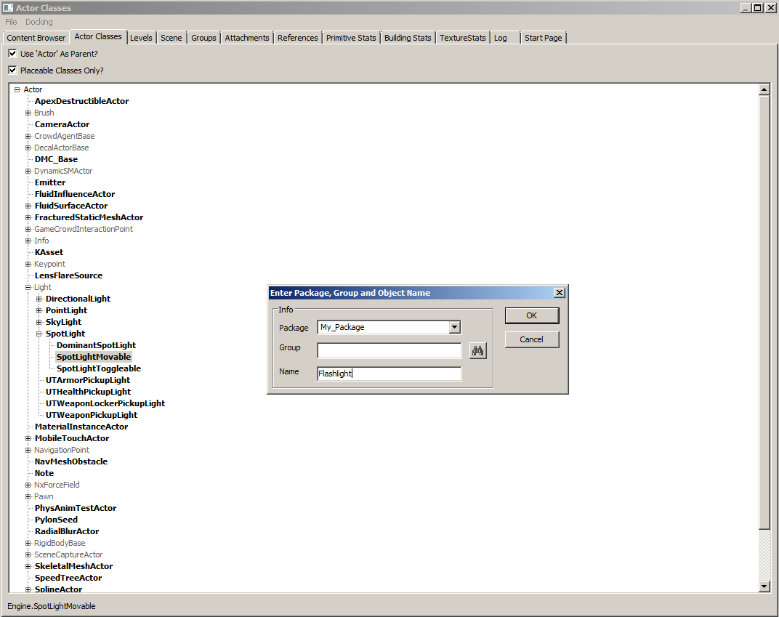

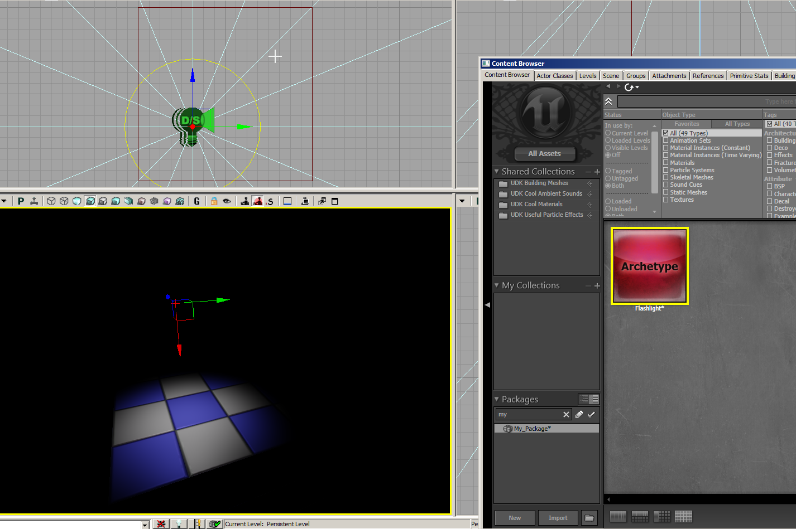

1. Add the new flashlight onto the scene. Orrientation or position is irrelevant

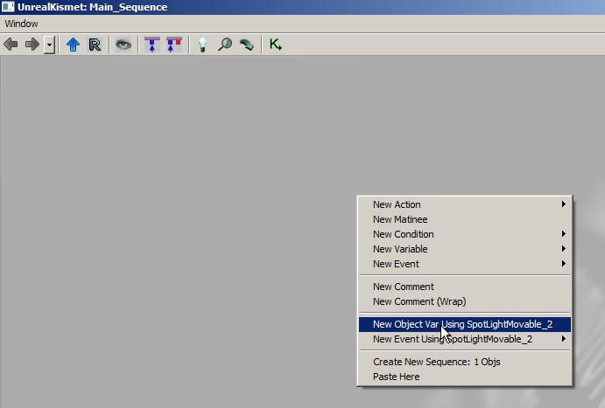

3.)Now. Open the Kismet Editor. Create a “New Object Var Using SpotlightMovable_2”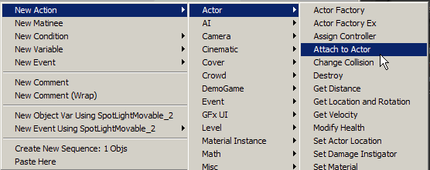

4.)Create a New Action “Attach to Actor”

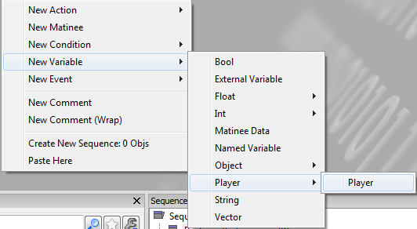

5.) Create a new variable “Player”

You should end up with this.

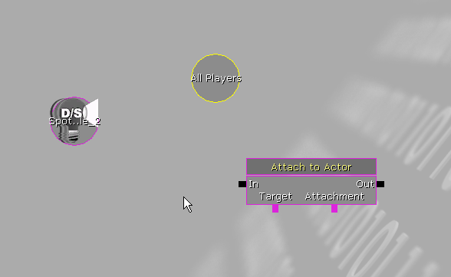

6.)Create a new Event node “Level Loaded”

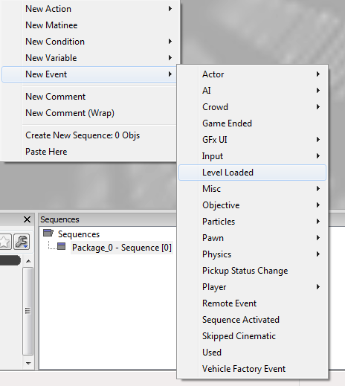

7.) Now. Connect everything like so. Remember to attach the properties to the “Attach To Actor” Node listed on the picture. WORD FOR WORD.

